SUBCOURSE EDITION
IT0426 D

US ARMY INTELLIGENCE CENTER

WEATHER SUPPORT TO
TACTICAL OPERATIONS

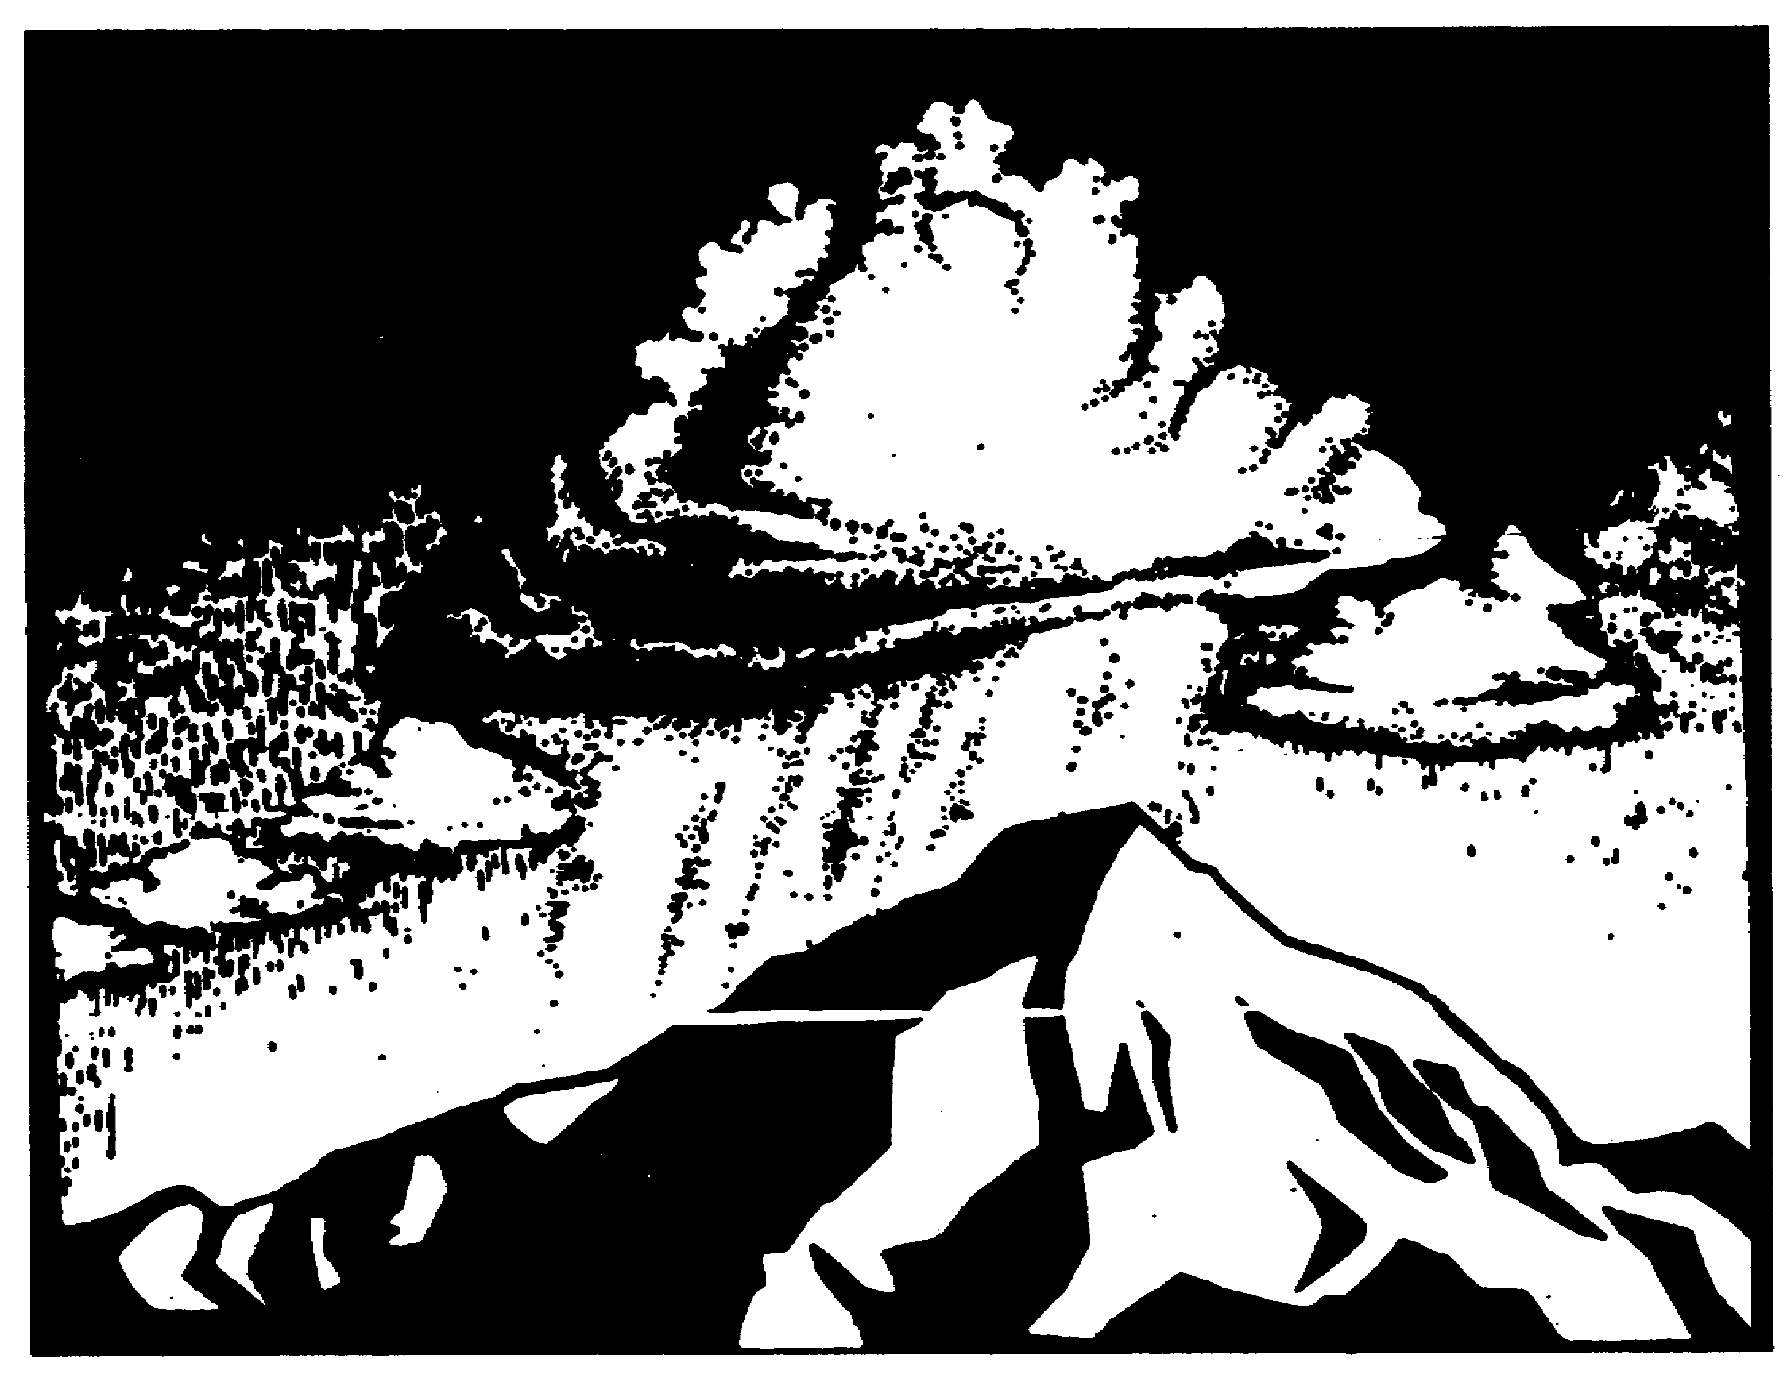

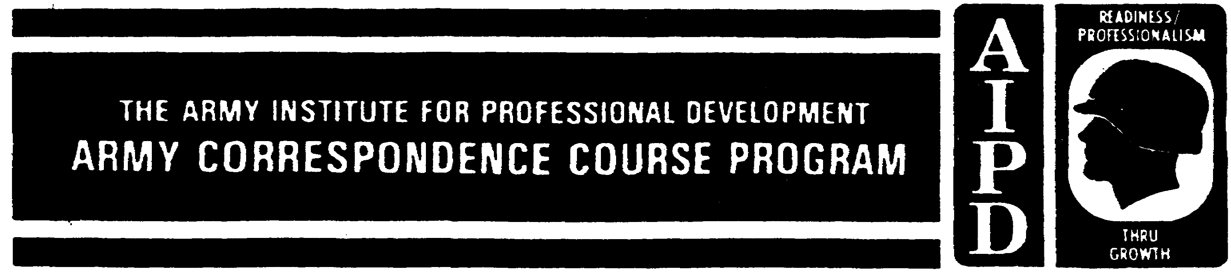

WEATHER SUPPORT TO TACTICAL OPERATIONS

Subcourse Number IT0426

EDITION D
United States Army Intelligence Center
Fort Huachuca, Arizona 85613-6000

4 Credit Hours

Edition Date: September 1999

SUBCOURSE OVERVIEW

This subcourse is designed to teach you the effects of weather on tactical operations. Contained within this subcourse are instructions on sources of weather information; weather terminology; weather products; key players, to include the intelligence officer, involved with weather, and how weather is incorporated into the intelligence preparation of the battlefield (IPB).
There are no prerequisites for this subcourse.

This subcourse reflects doctrine which was current at the time the sub- course was prepared. In your own work situation, always refer to the latest publications.

The words "he," "him," and "men," when used in this publication, represent both the masculine and feminine genders unless otherwise stated.

TERMINAL LEARNING OBJECTIVE

TASKS: You will define the difference between weather information and intelligence, perform battlefield evaluation, identify the effects of weather on threat/friendly courses of action, determine availability and capability of collection resources and develop weather situation templates in support of IPB.

CONDITION: You will be given narrative information and illustrations from AR 380-5, AR 380-20, FM 34-3, FM 34-60, and FM 34-81.

STANDARD: To demonstrate competency of this task, you must achieve a minimum of 70 percent on the subcourse examination.

i IT0426

TABLE OF CONTENTS

Section Page

Subcourse Overview i

Lesson: Weather Support to Tactical Operations 1-1

Introduction 1-1
Part A: Weather Intelligence and Support 1-2
Part B: Historical Use of Weather Information 1-4
Part C: Weather Information Sources 1-5
Part D: Weather Elements and Terminology 1-7
Part E: Meteorological Products 1-15
Part F: Weather Analysis in IPB 1-21
Practice Exercise 1-32
Answer Key/Feedback 1-34

Appendix A: Weather Effects on Operations A-1

Appendix B: ACRONYMS B-1

IT0426 ii

LESSON

WEATHER SUPPORT TO TACTICAL OPERATIONS

Critical Tasks: 301-372-2005
301-372-2014
301-372-2017
301-372-2050
301-372-2052
391-372-2057

OVERVIEW

LESSON DESCRIPTION:

This subcourse is designed to teach you the effects of weather on tactical operations. Contained in this subcourse are instructions on sources of weather information; weather terminology; weather products; key players, to include the intelligence officer, involved with weather; and how weather is incorporated into the intelligence preparation of the battlefield (IPB).

TERMINAL LEARNING OBJECTIVE

TASKS: Define the difference on and procedures required to identify sources of weather information, weather terminology, weather products, and weather effects on tactical operations.

CONDITIONS: You will be given narrative information and illustrations from AR 380-5, AR 380-20, FM 34-3, FM 34-60, and FM 34-81.

STANDARDS: You will provide weather support to tactical operations in accordance with the provisions of FM 34-3.

REFERENCES: The material contained in this lesson was derived from the following publications:

AR 115-10 FM 34-81
FM 100-5 FM 34-3
FM 101-5 FM 34-80
FM 30-10 FM 34-1

INTRODUCTION

Weather is critical to Army operations. Reliance on mobility of integrated air and ground operations to see and attack deep are affected by weather. Weapon and support systems depend on favorable conditions for accuracy and effectiveness. Every operation, piece of equipment, and person on the battlefield must be aware of, and be prepared for, the impact it will have on their operations. Commanders take advantage of weather conditions and plan operations to minimize weather's adverse effects.

1-1 IT0426

The command's intelligence officer is responsible for providing information on threat, weather, and terrain to his commander and staff. Weather information is a part of intelligence as enemy and terrain data, and is just as significant as enemy intentions and trafficability assessments.

The most significant factor in the commander's decision-making process is the impact of weather on friendly and enemy operations.

PART A - WEATHER INTELLIGENCE AND SUPPORT

Weather Analysis. There is a distinction between weather information and weather analysis. Weather information is the condition and behavior of the atmosphere at a given place and at a given time. Weather analysis is the effects of weather on our forces and the enemy. It is a part of intelligence used for planning and conducting combat operations. It impacts on the forces which can and cannot be used, it affects the types and levels of combat support and combat service support required to sustain operations.

Weather Support. Weather support to Army operations is based on four principles and is provided by the US Air Force (USAF) Air Weather Service (AWS) and Army artillery meteorological sections.

- The deployment, employment, and logistical support of all tactical units are affected by atmospheric conditions.

- Commanders must consider all weather factors, both favorable and unfavorable to determine the best courses of action for mission accomplishment.

- Meteorological data are highly perishable, because of continually changing atmospheric conditions. As a result, weather observation and forecasts must be constantly monitored and updated.

- Weather support requires dedicated, reliable communications.

Intelligence Officer. Weather intelligence is the responsibility of the intelligence officer. He is supported by a USAF staff weather officer (SWO) who commands a staff weather team (WETM) in support of the commander and the engineer terrain analysis team. The intelligence officer, the terrain analysis technician of the topographic support team, and the SWO comprise "the integrated weather support team."

The Deputy Chief of Staff for Intelligence (G2) at corps and division and the intelligence staff officer (S2) at brigade and battalion, have staff responsibility for weather analysis at their respective echelon. Each ensures all critical weather data required for his unit's current and projected operations are reviewed on a timely basis and integrated into the planning cycle.

The intelligence officer's responsibilities are:

- Interprets, in coordination with the terrain analysis technician, the effects of weather on Army weapon systems and tactics.

- Interprets enemy potential to exploit the use of weather and weather modification through tactics and operations.

IT0426 1-2

- Knows where to obtain weather data/information and the types of weather products available to him.

- Coordinates with the SWO to ensure correct analysis of weather information that affects intelligence.

- Coordinates and consolidates the commander's requirements for weather support.

- Coordinates with the SWO and artillery commander to arrange for the timely exchange of meteorological information.

- Disseminates processed weather information and intelligence to appropriate command elements.

- Coordinates weather training requirements of Army personnel with the G3/S3 and the commander.

- Assists the SWO in his special/general staff relations.

- Informs subordinate Army units of weather observations requested by the SWO. The G2/S2 instructs subordinate units on what information is required, where and when it is required, and how it is to be forwarded.

- Receives required information from the SWO and disseminates weather intelligence via electrical means, briefings, and written studies.

- Integrates weather intelligence into the advance planning to ensure the weather is incorporated into future operations.

- Ensures all AWS elements within the organization's area of responsibility are provided sufficient Army communication, logistical, and administrative support to complete their support mission.

- Receives from the chemical staff officer interpretations of fallout prediction and travel of fallout clouds as based on data provided by artillery meteorological sections and the AWS weather teams.

- Coordinates with the SWO and subordinate unit intelligence officers to obtain results of the Forward Area Limited Observation Program (FALOP).

Staff Weather Officer (SWO). An Air Force officer attached to Army commands, working under the supervision of the G2/S2. He advises the tactical commander on all matters pertaining to weather and climate. (For more information, see part C of this text).

Engineer Detachments (Terrain). Engineer topographic support teams produce detailed terrain-related graphic and textual data in direct support of the corps and division. The terrain analysis technician assess the impact of weather events on weapon systems, equipment, personnel, and tactics.

1-3 IT0426

PART B - HISTORICAL USE OF WEATHER INFORMATION

The Normandy invasion in France during World War 11 is a classic use of weather in planning a military operation.

Weather Analysis for the Invasion. In planning the Normandy invasion, it was not clear what constituted good invasion weather because of the short channel distance between France and England. The Dieppe Raid on the coast of France earlier had been carded out on a perfectly clear morning. Allied troops, lacking protection from fog or low cloud cover, were cut down on the beachhead by German shore batteries.

Planners realized the launching of a large-scale operation, during very rough weather was a high risk which might hamper the movements of allied ships and jeopardize the landing craft. It was obvious D-Day weather would have to be a compromise among many different requirements, none of which could be completely satisfied. There had to be enough wind to create choppy seas and make allied landing craft poor targets for the enemy artillery, yet not too much wind to prevent safe landings. Allied armor would need terrain firm enough for movement when they reached the beach. In short, the weather had to inconvenience the enemy while aiding the allies.

Using climatic studies, weather personnel determined the months of May, June, and July would probably have the most favorable invasion weather. In the latter part of May, a long-period forecast helped set the date for the invasion as 5 June 1944. This forecast showed the odds for getting the desired weather conditions were extremely poor and the invasion would probably have to go with conditions which were less than ideal.

Classic Weather Pattern. On 4 June 1944, American and British forecasters anxiously examined maps and weather charts. Soon, a classic weather pattern began to emerge. It was a cold front. This cold front was closing in on the United Kingdom from the central Atlantic Ocean. As they have done everyday for weeks, the British and American weather personnel held a hurried conference and then rushed their forecasts to the supreme headquarters of the allied powers in Europe. Not only would the weather on 5 June be overcast, stormy with high winds and a cloud base of 500 feet down to zero, but the weather was such that forecasting for more than 24 hours in advance was highly undependable. Based upon this short-range forecast, D-Day was moved one day to 6 June.

Favorable Weather for the Invasion. The 6th of June showed that out of the next five days, the 6th offered the greatest possibilities for favorable weather. On the morning of 5 June, as the cold front passed over England, bringing rain and stiff winds to buffet the coast, General Ike' Eisenhower balanced the critical invasion factors one against the other. The cold front extended from Scotland to the Cherbourg Peninsula of France with clouds, rain, and high winds. The weather forecast for 6 June, though far from satisfactory, met the bare minimum requirements previously set for the invasion. Yet with ships, planes, and troops poised to strike, it was impossible to hold back much longer. General Eisenhower waited 24 hours while the front crossed the channel, and then poured an estimated 150,000 troops onto the Normandy beachhead.

An important aspect of this particular weather situation concerns the weather forecast provided to the German commanders by their own meteorological section. Based upon their predictions,

IT0426 1-4

it was determined it would be virtually impossible for the allies to launch an invasion during this time period. In fact, based on the German forecast, Field Marshal Rommel, thoroughly convinced there would be no invasion, went back to Germany to be with his wife on her birthday and was not present to direct his forces when the invasion did come. Thus, the actual weather situation aided the allies in achieving tactical surprise.

PART C - WEATHER INFORMATION SOURCES

Sources of weather/meteorological information support both Air Force and Army acquired data from intermittent measurements to detailed observations taken on a regular schedule by trained weather observers. The USAF, AWS, WETMs, the artillery meteorological sections, and Defense Meteorological Satellite Program provides weather information.

Air Weather Service. Under the command of the USAF Military Airlift Command (MAC), the AWS is the organization responsible for obtaining, evaluating, and disseminating weather information for the Army. Forecasts are provided by the AWS to theater or joint task force level, and by a WETM at corps, division, separate brigade, and units below these echelons.

AWS sections supporting Army tactical units will be organized, equipped, and trained to react to and operate at all levels of conflict from fixed to field environments. AWS sections receive logistical, communication, and administrative support from the Army.

Weather Team. USAF provides to the host military intelligence unit the support of AWS unit during tactical operations and training. The WETM under the G2/S2 is organized with SWO, tactical operations center (TOC) forecast element, and weather observation teams. A USAF WETM provides operational weather support to corps, divisions, separate brigades, and armored cavalry regiment (ACR) and provides current and future weather conditions, warnings of weather conditions that affect operations, personnel, material, weapon systems, movement routes, target areas, and terminals.

Staff Weather Officer is the senior weather section representative and a member of the special staff. He is the principal advisor to the commander and is the senior representative on the staff with operational weather support capabilities provided by AWS. He normally operates in the analysis and control element (ACE) of the TOC support element.

Tactical Operations Center Forecast Element maintains the weather data base, analyzes weather data, and issues tailored weather information to agencies and in-flight pilot reports. The element operates at the main command post (CP) outside the TOC area.

Weather Observation Teams. At corps, two weather observation teams are located at the corps airfields. They take observations and measurements to satisfy local requirements. At division, weather observation teams are located at landing zones and brigade forward areas.

Artillery Meteorological Section. Within an Army command, artillery meteorological sections acquire atmospheric soundings and surface weather observations and disseminates current meteorological data. Each division, separate brigade, and field artillery brigade/group has one artillery meteorological section. These sections are not trained or equipped to make weather forecasts, but provide the following requirements, as required:

1-5 IT0426

- Meteorological data for fallout prediction -Fallout Data Reports.

- Computer meteorological messages -Computer Data Reports.

- Upper air weather data to the AWS weather team -Meteorological Reports.

- Limited surface weather observations -Surface Data Reports.

- Target acquisition message -Sound-Ranging Reports.

Mission requirements given for sound-ranging messages can be fulfilled by obtaining low-level wind and temperature observations. The requirement for surface weather observations can be satisfied by acquiring regularly scheduled limited surface observations.

The data obtained by an artillery meteorological section can be vital in developing tactical weather forecasts. Also, data collected by the AWS can help the artillery meteorological section perform its other missions. Therefore, corps and division SWOs, fire support elements, and artillery meteorological sections must develop a close working relationship. Standard operating procedures (SOPs) should specify the support requirements, scheduling, and mode of communication for expeditious data exchange.

The division artillery S2 and the corps artillery meteorological sections should maintain close contact with the attached WETM to ensure upper air sounding data are provided to the WETM in a timely manner. The WETM can then provide weather support to the artillery meteorological sections when required.

If the artillery meteorological section loses the capability, limited weather data for artillery support may be obtained from the WETM.

Brigade and Battalion Intelligence Officer. Another major source of tactical weather information is provided by brigade and battalion intelligence officers under the Forward Area Limited Observing Program (FALOP). FALOP is a program which S2s are tasked to take, record, encode, and transmit limited weather observations from areas forward of the division CP.

FALOP. The Armywide FALOP is designed to obtain timely weather observations from the forward areas of the battlefield. At maneuver brigade and battalion level, the only immediate source of weather observations are from the FALOP. S2s collect local weather information and transmit it to the USAF WETM via intelligence communication lines. The WETM uses the information in preparing tailored tactical weather support products.

The FALOP program requires observations at sunrise, noon, and sunset. Observed data includes:

- Surface wind speed and direction.

- Surface visibility.

- Present weather and obstruction to vision.

IT0426 1-6

- Amount of cloud cover.

- Height of the clouds (low, middle, or high).

- Road conditions (dry, wet, mud, or snow).

- Terrain conditions (dry, wet, mud, or snow).

- Water body conditions (normal, high, or ice).

- Air temperature.

- Remarks.

Weather observation is taken by a single person using a belt weather kit. The kit contains five instruments and weighs only 1.5 pounds. The information is encoded into a 14-digit code for easy dissemination. The time to take, record, encode, and transmit an observation is approximately 15 minutes.

Defense-Metrological Satellite Program. The Defense Meteorological Satellite Program (DMSP) is a joint service program that provides high-quality data for support of special strategic missions, tactical air and ground operations, and research and development in advancing meteorological satellite technology. DMSP satellites provide visual, infrared, and high resolution data to AWS transportable terminals as the satellites pass over or near the area.

These receivers can be airlifted by C-141, C-5, or C17 aircraft or transported over improved roads. Sensor packages programmed for future DMSP satellites include microwave images for precipitation location and intensity measurements, soil moisture measurements, and advance temperature/humidity sounders.

Other Army Sources of Weather Data. Other Army organizations that obtain and report weather data are:

- Aviation and air traffic control and imagery analysis units.

- Engineer and artillery survey units, terrain and topographic units.

- Ground reconnaissance and special forces elements.

Collectively, these units can provide a variety of low-level on-site observations of; surface temperature, wind direction and speed, surface pressure, altimeter setting, visibility, special phenomena, sky cover, cloud height, precipitation amount, snow depth, and winds aloft. From ground observers, aircraft, and ground radars; information on sky cover, visibility, precipitation, and special phenomena over friendly and enemy territories.

PART D - WEATHER ELEMENTS AND TERMINOLOGY

The intelligence officer must be aware of the elements of weather and climate and understand weather terminology.

1-7 IT0426

Weather is the sum total of weather elements for a short period of time and the momentary state of the atmosphere. Climate, on the other hand, is a composite or generalization of the variety of day-to-day weather conditions over a period of years.

The physical properties and conditions of the atmosphere which must be observed or measured to describe the state of the weather are known as weather elements. The most important elements are air temperature, barometric pressure, wind, water vapor; the type, amount, and height of clouds; the type, intensity, and amount of precipitation, and the visibility it allows, and fog.

Light data, windchill index, and wet-bulb-globe-temperature (WBGT) index are important elements in calculating the impact of weather.

Air-Temperature is determined by use of a thermometer. Thermometers are calibrated using the melting point of ice and the boiling point of water at sea level as standard reference points.

The Fahrenheit scale is used in the US, with the melting point of ice designated as 32° Fahrenheit above zero and the boiling point of water as 212° above zero. Countries using the metric system use the centigrade or Celsius scale. It has the freezing point of water set at 0° and the boiling point set at 100°. Temperature may be converted from one scale to the other by using the following formulae:

C = 5 (°F-32°)
9

F = 9 X°C + 32°
5
Barometric Pressure (Air pressure) is the force exerted on a unit or area by the weight of the atmosphere from the level of the measurement to the top of the atmosphere; the air pressure at a specified altitude. The average pressure at sea level is 14.7 pounds per square inch. Mean sea level is used as a reference for surface weather observations. Pressure measurements are shown on weather maps and climatic charts as if the entire surface of the earth were at sea level. Atmospheric pressures are recorded at various altitudes to provide data for estimating nuclear weapon effects.

Wind is air which is in horizontal or near horizontal motion; vertical movements of air are known as air currents. To describe the air movement (wind), we must measure or estimate its direction and speed.

Wind direction is measured by a wind vane. Wind direction is determined by the direction from
which it is blowing. A south wind, for example, blows from south to north.

Wind speed is measured by several types of instruments called anemometers. When no anemometer is available, wind speed may be estimated by observing the effects of the wind on surrounding objects. The Beaufort Scale (Table 1) is used as an aid in estimating wind speed.

Water Vapor is the most important part of the atmosphere that determines weather phenomena. Although the oceans are the primary source, a limited amount of water vapor is furnished to the

IT0426 1-8

Table 1. Beaufort Scale.

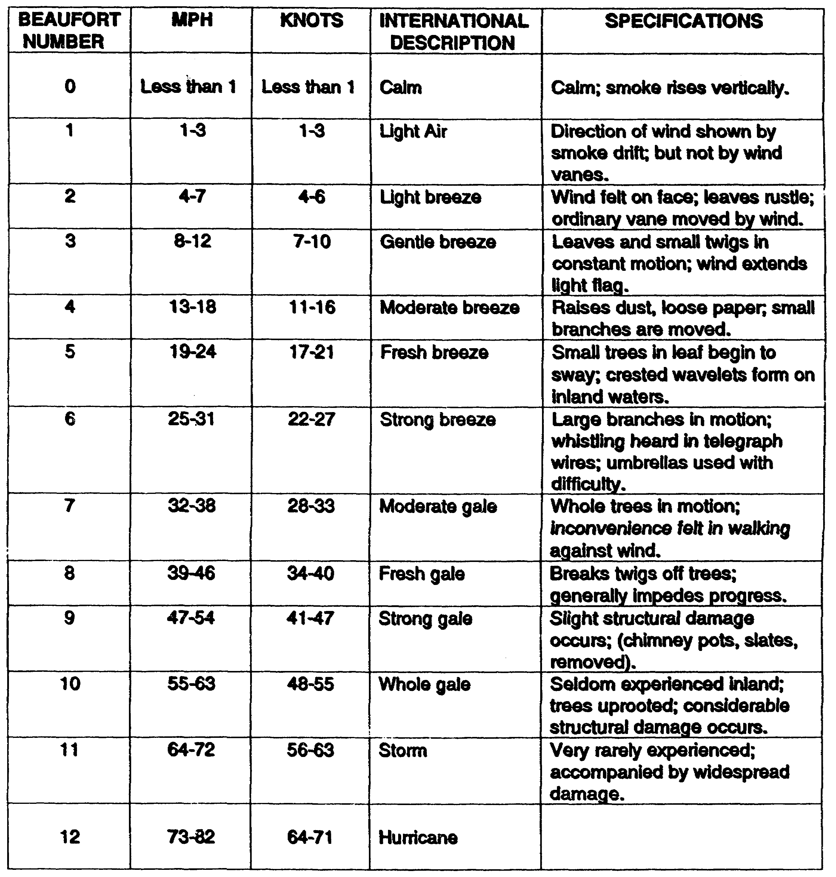

atmosphere from lakes and rivers, snows, ice fields, and vegetation. The percentage of water vapor by volume in the air may vary from practically zero in deserts to 4 to 5 percent in humid tropical areas.

Humidity is the term used to describe the amount of water vapor in the air. The amount of water vapor the air actually contains compared with the maximum it can hold at a given temperature and

1-9 IT0426

pressure is termed the relative humidity of the air. Since the amount of moisture actually in the air is normally fixed, the relative humidity changes as the air temperature changes, being the highest percentage in the low temperatures before dawn and the lowest during the warming of the afternoon. When a specific volume of air holds all the moisture it can at a given temperature, it has become saturated and any additional moisture or cooling of the air will cause water vapor to condense into clouds, fog, or dew. This air is described as having a relative humidity of 100 percent.

Dewpoint is the temperature to which air must be cooled at constant pressure and water vapor content for saturation to occur. Since water vapor content is normally a fixed quantity, the dewpoint of a volume of air remains constant as the temperature rises and falls during a day. The closer the dewpoint temperature is to the actual air temperature, the greater the likelihood that cooling of the air at night will lead to saturation of the air and subsequent formation of fog or clouds.

Clouds are masses of condensed moisture suspended in air, either in the form of minute water droplets or ice crystals. The AWS observes and reports the types of clouds present, the heights of cloud bases, the amount of clouds present, and, for thunderstorms, the direction clouds are moving.

Cloud Cover is reported in terms of the percentage of sky covered by clouds. The following terms are used in reporting cloud cover:

- Clear--No clouds, or less than 0.10 sky is covered.

- Scattered--0.10 to 0.50 sky is covered, inclusive.

- Broken--0.60 to 0.90 sky is covered, inclusive.

- Overcast--More than 0.90 is covered.

Cloud Heights are reported in meters above the ground. The heights of clouds below 1,500 meters (5,000 feet) are reported to the nearest 30 meters (100 feet); clouds from 1,5000 to 3,000 meters (5,000 to 10,000 feet) are reported to the nearest 150 meters (500 feet); and clouds above 3,000 meters are reported to the nearest 300 meters (1,000 feet). A ceiling is defined as the height of the lowest layer of clouds or obscuring phenomena reported as broken, overcast, or obscured and not classified as thin or partial.

Cloud Direction is the direction toward which the cloud bases are moving. It is reported according to the eight points of the compass (N, NE, E, SE, S, SW, W, NW).

Cloud Families. Clouds (figure 1-1) may be grouped into four families.

- High. Cirrus, cirrostratus, and cirrocumulus.

- Middle. Altostratus and altocumulus.

- Low. Stratus, nimbostratus, and stratocumulus.

- Vertical development. Cumulonimbus is an example.

IT0426 1-10

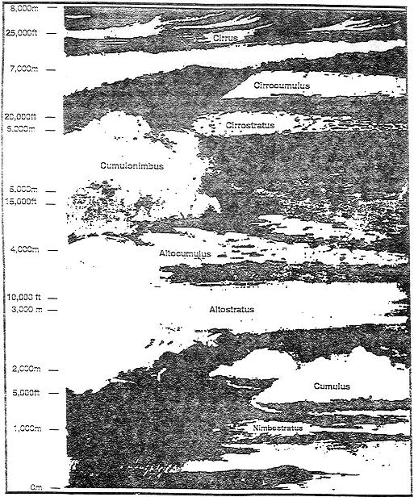

Figure 1-1. Major Cloud Type.

1-11 IT0426

High clouds usually occur at heights from 6,000 to 12,000 meters (20,000 to 40,000 feet). They may be found at lower altitudes in polar regions. They are composed of ice crystals;.

Middle clouds usually occur at altitudes of 1,800 to 6,000 meters (6,000 to 20,000 feet). They are located in the lower limit of this range in the colder seasons and near the upper limit: in the warmer seasons.

Low clouds usually have bases below 1,800 meters (6,000 feet). Light snow and drizzle to continuous rain and snow are common to these cloud systems.

Vertical development clouds cannot be classified according to height because they extend through all the levels assigned to other cloud groups. The bases vary from 150 to 3,000 meters (500 feet to 10,000 feet) or higher, while the tops may vary from 450 to more than 12,000 meters (1,500 to 40,000 feet). They all occur in relatively unstable air and are frequently associated with strong vertical currents and intense turbulence. Thunderstorms, squalls, and hail are characteristics of a vertical cloud.

Precipitation is visible moisture that falls from the atmosphere, such as rain, sleet, snow, hail, drizzle, or a combination of these. As an air mass rises, its ability to hold moisture decreases and clouds form. When the cloud droplets become too large to remain in suspension, rain occurs; if the air temperature is below freezing, snow is formed. Sleet is frozen rain formed when it passes through a layer of below-freezing air. Hail consists of rounded particles composed of layers of ice falling from cumulonimbus (vertical clouds) with strong updrafts. Freezing rain falls from the air in liquid form but freezes upon contact with objects on the surface that are below freezing. The ice formed on these surfaces is called glaze.

Character of precipitation is reported as continuous, intermittent, or showery. Continuous precipitation, the intensity increases or decreases gradually. Intermittent precipitation, the intensity changes gradually, but stops and starts at least once an hour. Showery precipitation, is rapid changes in intensity and abrupt starting and stopping.

Intensity of precipitation is determined generally on the basis of the rate of fall of the precipitation and is reported as follows:

- Very light--Scattered drops or flakes which do not completely wet an exposed surface regardless of duration.

- Light--a trace of 0.10 of an inch of precipitation per hour; maximum 0.01 of an inch in six minutes.

- Moderate--0.1 1 to 0.30 of an inch per hour; between 0.01 and 0.03 of an inch in six minutes.

- Heavy--more than 0.30 of an inch per hour; more than 0.03 inches in six minutes.

In case of snow or drizzle, which significantly reduces horizontal visibility, intensity is the reduction in visibility, as follows:

- Very light--same as above.

IT0426 1-12

- Light--visibility 5/8 statute mile or more.

- Moderate--visibility less than 5/8 statute mile, but not less than 5/16 statute mile.

- Heavy--visibility less than 5/16 statute mile.

Visibility is the mean distance at which the naked eye can see prominent objects through the atmosphere.

Fog is a mass of small water droplets suspended in the atmosphere at the surface of the earth that reduces the horizontal visibility. It is formed by the condensation of water vapor in the air. The most favorable conditions for the formation of fog are an abundance of water vapor, high relative humidity, and alight surface wind. Fog is usually more prevalent in coastal areas than inland because there is more water vapor in the air. Inland fogs may be very persistent in industrial regions and in major river valleys. In most areas of the world, fog is more frequent in the colder seasons than it is in the warmer seasons.

Light Data a term used to describe twilight periods before sunrise and after sunset. It is expressed in the number of degrees the center of the sun is below the horizon. Although it is not weather data, it is customarily considered together with weather factors because both affect visibility. WETMs provide light data information (Table 2).

Table 2. Light Data.

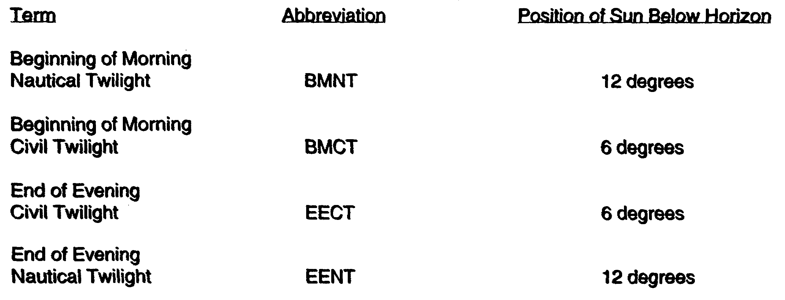

Under ideal conditions, the period of time when there is adequate visibility for large-scale operations is between BMCT and EECT. Generally, visibility at BMNT is about 400 meters, this would be enough light for close coordination between personnel. At halfway between BMNT and BMCT (or EECT and EENT), there is enough light for visual ground adjustment of close-in artillery fire and air strikes.

Windchill Index. The windchill index aids in planning protective measures required to prevent or reduce cold injuries. This index was developed by the US Army Medical Service and is used as a guide to the cooling effect of wind on bare flesh when first exposed. Windchill danger exists if the person is exposed to wind created by a moving vehicle, helicopter rotors, propeller

1-13 IT0426

blast, or other similar artificial sources. It is the rate of relative air movement that counts. See Table 3 for the Windchill Index.

The cooling effect is the same whether the human body is moving through the air or the air is blowing past the body. The effect of wind will be less if a person has even slight protection for exposed parts-light gloves on hands, parka hood shielding face, and so on.

Danger is less if the individual is active. A person produces about 100 watts (341 British Thermal Units (BTUs)) of heat standing still, but up to 1,000 watts (3,410 BTUs) in vigorous activity like cross-country skiing.

There is no substitute for common sense. Table 3 is a guide to the cooling effect of the wind on bare flesh when the person is first exposed. General body cooling and many other factors affect the risk of freezing injury.

Table 3. Windchill Index.

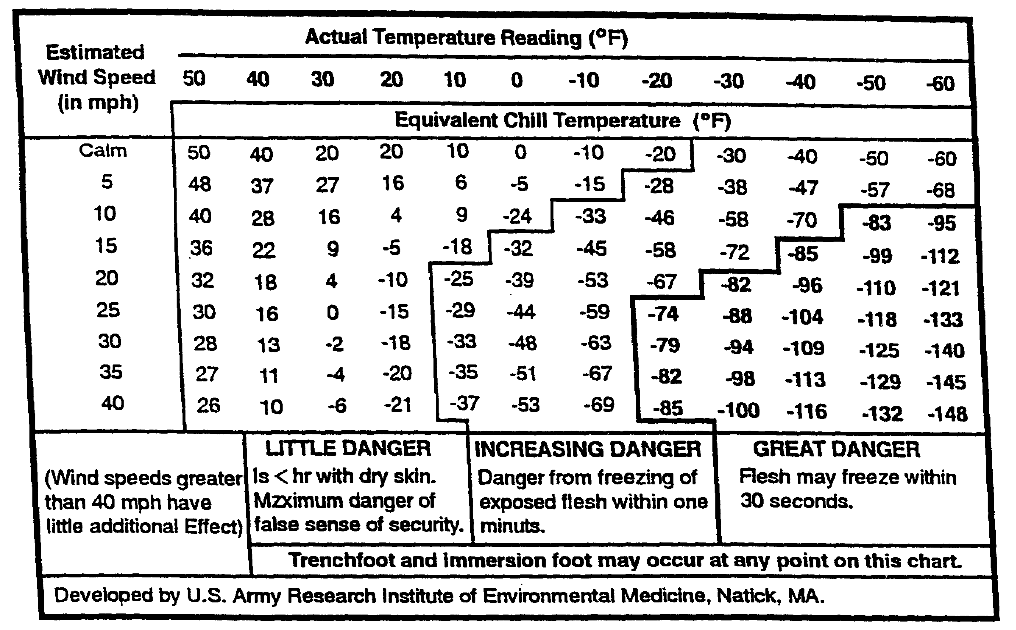

MEASURE LOCAL TEMPERATURE AND WIND SPEED IF POSSIBLE; IF NOT, ESTIMATE, ENTER TABLE AT CLOSEST 5°F INTERVAL ALONG THE TOP AND WITH APPROPRIATE WIND SPEED ALONG LEFT SIDE. INTERSECTION GIVES APPROXIMATELY EQUIVALENT CHILL TEMPERATURE, THAT IS, THE TEMPERATURE THAT WOULD CAUSE THE SAME RATE OF COOLING UNDER CALM CONDITIONS.

Wet-Bulb-Glove-Temperature (WBGT) Index. The WBGT index is an indicator of loss of physical effectiveness due to a combination of temperature, humidity, and wind. The

IT0426 1-14

measurements must be taken in a location which is the same as, or closely approximates, the environment to which personnel are exposed. The WBGT is obtained from supporting medical units. The proponents of the WBGT is obtained from supporting medical units. The proponents of the WBGT index have proposed the following standards for using the index:

- When the WBGT index reaches 78°F (26°C), extremely intense physical exertion may precipitate heat exhaustion or heat stroke. Caution should be taken.

- When the WBGT index reaches 82°F (28°C), discretion should be used in planning heavy exercise for unseasoned personnel.

- When the WBGT index reaches 85°F (29°C), strenuous exercise, such as marching at standard cadence, should be suspended for unseasoned personnel during their first three weeks of training. At this temperature, training activities may be continued on a reduced scale after the second week.

- When the WBGT index exceeds 85°F (29°C), outdoor classes in the sun should be avoided.

- When the WBGT index reaches 88°F (31°C), strenuous exercise should be curtailed for all recruits and other trainees with less than 12 weeks of training in hot weather. Hardened personnel, after having been acclimatized each season, can carry on limited activity at WBGT of 88°F to 90°F (31° to 32°C) for periods not exceeding six hours a day.

- When the WBGT index is 90°F (32°C) or above, physical training and strenuous exercise should be suspended for all personnel. This does not apply to operational commitments but only for training purposes, where the risk of heat casualties may be warranted.

- Add 10°F (6°C) to the measured WBGT when personnel are wearing body armor or NBC warfare protective clothing.

PART E - METEOROLOGICAL PRODUCTS

There are two types of meteorological products: primary products used by the SWO and WETM, and tactical weather products developed from the primary weather products used by the commander and staff. The types of weather products/information normally used by the SWO to support Army users, range from a simple verbal weather briefing to complex computer-produced products. In most cases, these weather products do not cover the effects of weather conditions for given situations. In coordination with the commander's staff, the SWO analyzes the tactical situation and determines which weather factors impact upon current and future operations.

Weather Observations contain information on existing weather conditions or weather elements at a specific location (surface or upper air).

- Surface observations of various weather parameters are taken hourly or as required. They include surface winds, prevailing visibility, weather, obstructions to vision, clouds,

1-15 IT0426

temperature, dewpoint, altimeter, and remarks. Additional parameters are pressure altitude, density altitude, surface pressure, snow depth, precipitation amounts, state-of-the-ground, maximum and minimum temperatures, and windchill index. WBGT is obtained from the medical units. Freeze-thaw depth, ice thickness, current, water depth, river stage, and trafficability are obtained from engineer units.

- Upper Air Observations are taken by artillery meteorological sections every two to four hours, or as required. They measure temperature, pressure, relative humidity, and azimuth/elevation angle of the balloon-borne instrument package from the release point. From these observations, artillery meteorological sections prepare fallout, wind, sound ranging, ballistic meteorological, and computer meteorological messages. Pressure, temperature, dewpoint, and winds aloft from the surface to a predetermined height are derived by the artillery meteorological sections. Parameters derived from the upper air observations by the USAF WETMs are depth of the surface mixing layer, height of inversion bases, icing, refractive index, fallout plots, and turbulence.

Weather Forecasts are statements of expected weather conditions at a point, along a route, or areas at a specified future time or period. Accuracy of a forecast depends on the length of the forecast period, amount and reliability of weather data, location terrain, season, communications, and experience of the forecaster. Forecasts do not exceed 72-hours, and are issued at 6- or 12-hour intervals, and includes the synoptic situations; sky condition; cloud bases and tips; visibility; precipitation; obstructions to vision; severe weather; temperature extremes; surface winds; light data; and additional information tailored to the particular operation.

- General Outlook. A 3-to 5-day general outlook is provided daily, and a 30-day outlook can be provided on request. These contain the same parameters as the short-term forecasts, but in more general terms.

- Aviation Forecasts are issued every 6 hours for a 24-hour period and provide cloud and ceiling conditions, visibility, winds (surface and aloft), turbulence and icing conditions, occurrence and type of precipitation, and obstructions to vision.

- Weather Watches are issued as required providing notice of the potential for extreme weather conditions to occur. Weather conditions are favorable for severe weather to occur in the area, but no confirmation of actual severe weather have been reported.

- Weather Warnings are issued as required providing notice of the occurrence of extreme weather conditions in the area; to include severe thunderstorms, tornadoes, hail storms, destructive winds, etc.

Climatic Summaries. Narrative statistical expressions of weather elements in terms of averages, extremes, and frequencies of occurrences over a period of time, along a route, or within an area.

Climatic Studies. Analyses and interpretations of climatic information to reveal problem effects of climate and weather on a specific operation or activity. Based on records of past weather n a given area, these studies range from an investigation of a variety of weather conditions over an entire country to an analysis of the local effects of a single atmospheric element. Climatic studies are of particular tactical value to combat and combat support units in anticipating engineering and logistical problems that may be encountered in a projected campaign.

IT0426 1-16

Weather Elements in Climatic Studies. Climatic studies for specific areas are provided by AWS units. The weather elements presented in a climatic study vary according to the user. The information generally includes, but is not limited to the following:

- Weather description. Brief description of prevailing weather for the period covered by the study.

- Temperatures. Expected temperatures and temperature variations for the period.

- Precipitation. Total amount of rain or snow expected including frequency and intensity; frequency and duration of wet or dry spells, blizzards, droughts, and probable standing snow cover.

- Expected winds. Direction and speed of prevailing winds and maximum winds that might be expected with severe weather.

- Cloudiness. Data on seasonal period of protracted cloudiness.

- Humidity. The percentage expected for the period.

- Severe weather. Probability of hurricanes, typhoons, thunderstorms, tornadoes, or dust storms.

- Effects of weather during NBC warfare. Effects of weather on transmission through the air of instantaneous nuclear and thermal radiation; the movement and concentration of contaminated clouds and dust; the spread of surface fires and other phenomena connected with nuclear warfare; and the effects on the use of chemical and biological weapons and agents.

NOTE: Defense planning must be considered against possible enemy use of NBC.

Special climatic Studies. Prepared for a specific engineering or logistical problem or to investigate in detail the effects of weather conditions in a particular operation. Such studies provide data in determining:

- Degradation in left capability of helicopters.

- Optimum runway orientation.

- Planning factors for construction schedules.

- Windchill factors for clothing requirements.

- Location of camps, training areas, and landing fields.

- Coastal areas suitable for amphibious operations.

- Seasonal fuel requirements by weight, quantity, and type.

1-17 IT0426

Special Area Studies used in early stages of planning, include the following weather information:

- Climate--type, general description, seasonal changes, and various climatic regions.

- Temperature--annual ranges and seasonal changes.

- Precipitation and winds--variations and amount of precipitation and its seasonal distribution, periods of storms and monsoons, prevailing winds (velocity), and periods of occurrence.

- Visibility--periods and zones of fogs and mists, cloudy seasons, and percentage of overcast skies.

Weather Briefings. Weather briefings are formal and impromptu. Of primary importance are the formal briefings on current and future weather conditions and weather problems impacting on the divisions of the commander and staff. Impromptu briefings for specific operations and missions are also available for Army users.

Tactical Weather Products. Required by each Army echelon, the tactical weather products are obtained by the SWO either from centralized facilities or locally. There is some variation in the type products the SWO uses to satisfy different echelons or commanders. Normally lower echelons are interested in short-range outlooks (up to 30 days). At higher echelons, the commander and staff are briefed by the SWO or by hard-copy products in graphic or alphanumeric form. Weather information interacts in the commanders decision-making process and the intelligence preparation of the battlefield (IPB) process. Specific battle decisions result from this type of weather support rather than general staff briefings. Products the commander and staff need are shown in Table 4. These tactical weather requirements are tailored by the SWO and WETM to mission and user requirements.

Other echelons from battalion down are provided remote weather support through intelligence or other communication links. The content and format of weather support products to other echelons are a function of the echelon being supported and the user's requirements.

IT0426 1-18

Table 4. Tactical Weather Support Products.

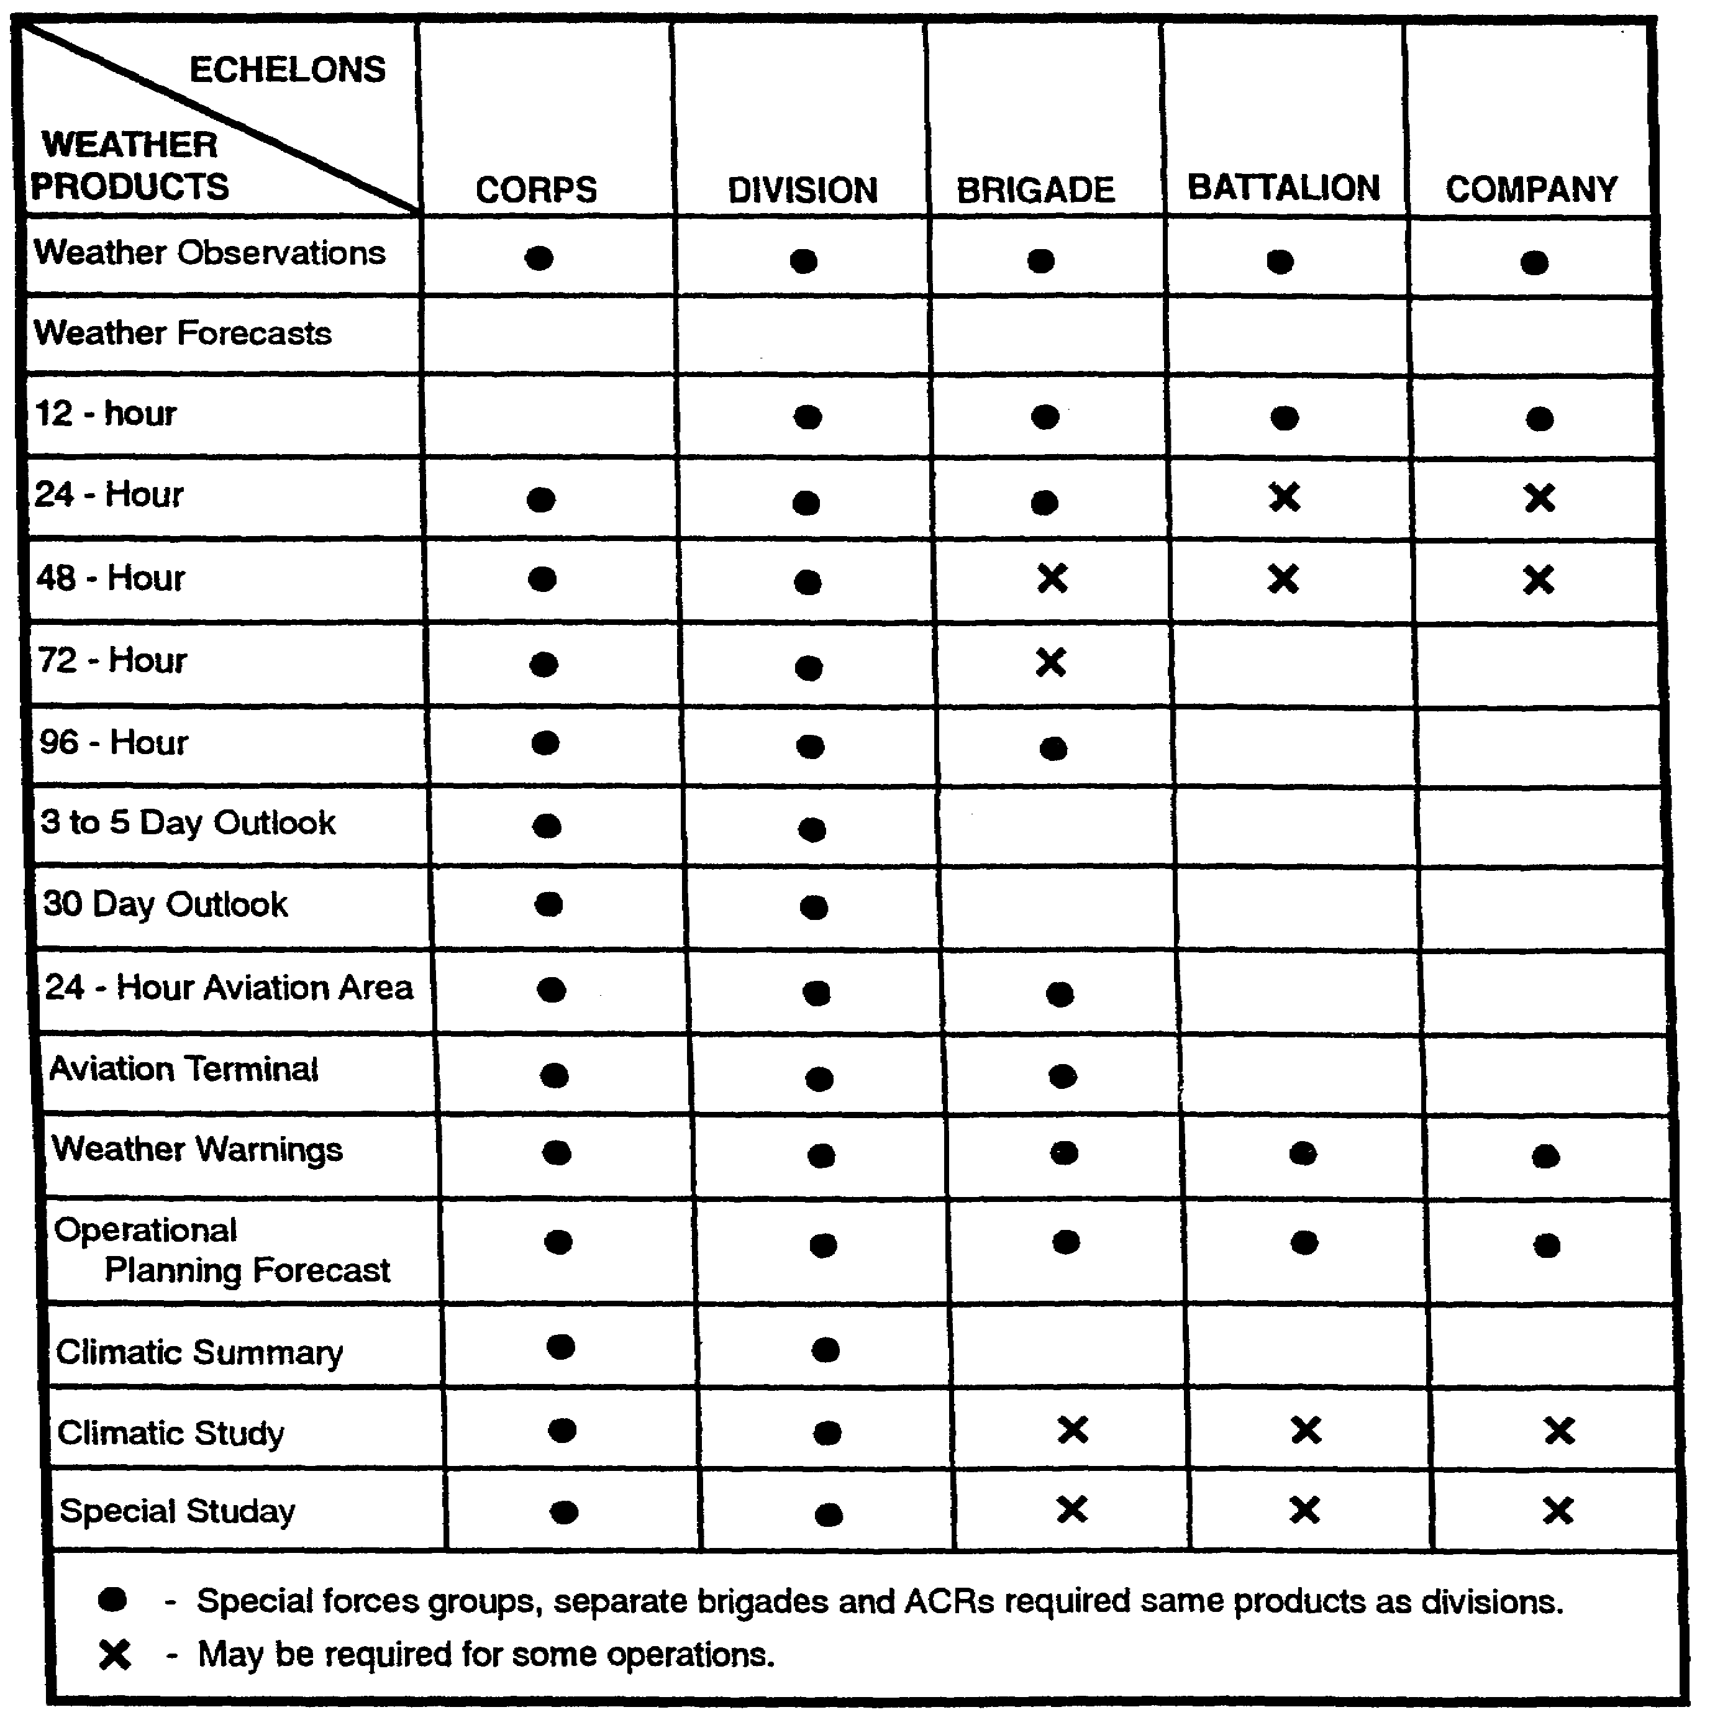

1-19 IT0426

Weather Parameter-Product Tabulation Matrix (Table 5) illustrates the weather products available.

Table 5. Weather Parameter-Product Tabulation.

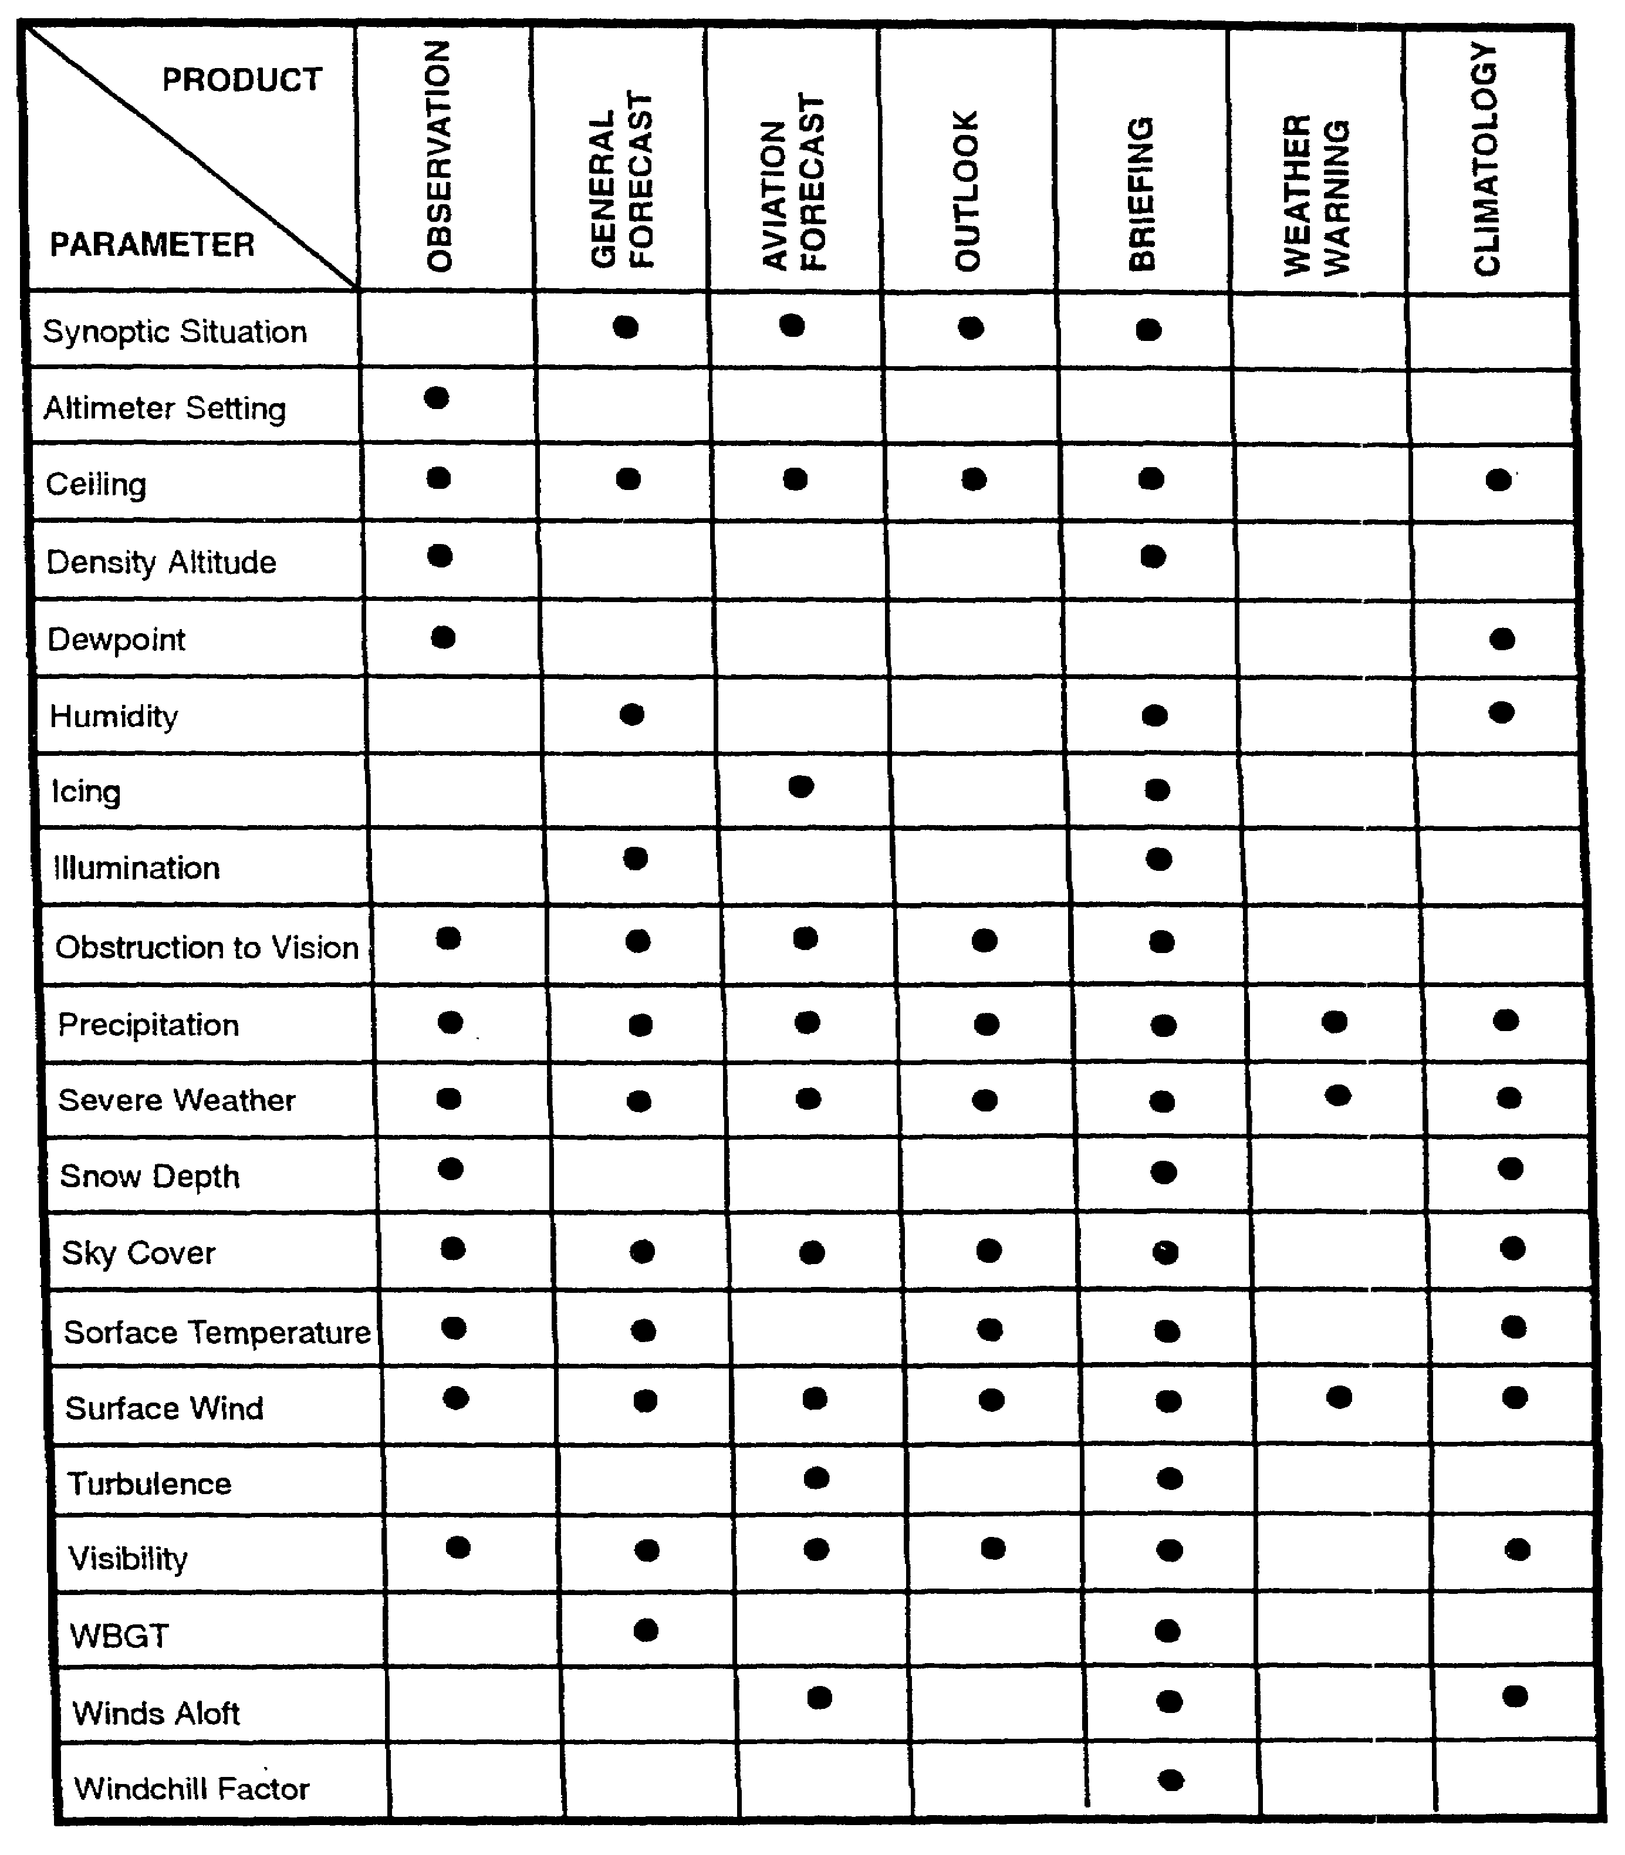

IT0426 1-20

PART F - WEATHER ANALYSIS IN IPB

Weather analysis is an integral part of the IPB process. IPB is a systematic and continuous approach to analyzing the enemy, weather, and terrain in a specific geographical area. It is tactical intelligence analysis performed before the next battle regardless of the existing conditions.

IPB accounts for the maximum integration of enemy, weather, and terrain information as it relates to battlefield conditions. This is done to evaluate and determine enemy capabilities, vulnerabilities, and possible courses of action. Graphics are basic to the IPB process and most intelligence can be communicated with pictures. These graphics include templates, terrain factor overlays, and weather factor overlays. The IPB weather products are used with the following traditional weather products: light data charts, 12-, 24-, 36-, and 72-hour forecasts, long-range forecasts, climatological and special studies.

Weather will vary with seasons. Analysts understand seasonal characteristics, and focus on those seasonal periods. For example, an area averages rainfall of 10 inches in the three summer months. If analysts use 10 inches of rainfall for determining trafficability, it may be concluded conditions will not support much movement during that period. But, one may find weather windows during the three-month summer period that would be favorable to cross-country movement.

REMEMBER: It was a weather window that permitted allied forces to invade Normandy in 1944; when US planes were grounded in Vietnam because of weather, the North Vietnamese Army resupplied its force in the south. Thus, favorable weather conditions for war are not always clear and sunny skies.

1-21 IT0426

IPB Five-Function Process. The IPB five-function process provides the intelligence analyst with the process to build the IPB product (Figure 1-2).

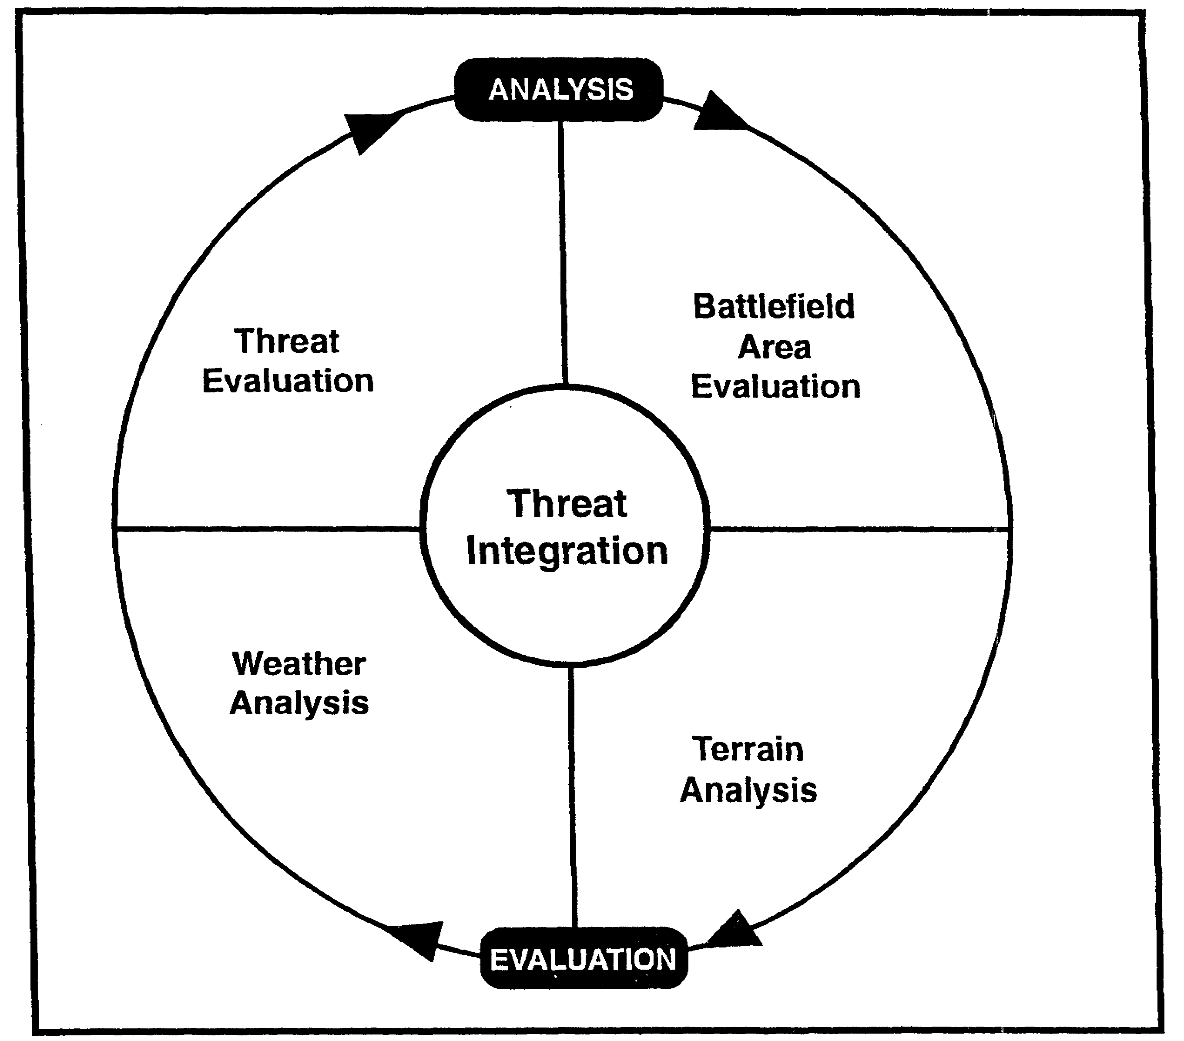

Figure 1-2. IPB Process Chart.

IT0426 1-22

Weather analysis (function 3) is accomplished by the SWO and the WETM in coordination with the G2, All-Source Production Section intelligence analysts, and terrain analysts from the Engineer Detachment (Terrain). Terrain and weather analysis may be accomplished in sequence or simultaneously with threat evaluation. This function focuses on the militarily significant aspects of weather and how they apply to the commander's battlefield area.

IPB Weather Overlays. IPB techniques emphasize the use of overlays to show impacts on friendly and enemy capabilities to move, shoot, and communicate. Priority for weather overlays is situation dependent because of tactical situations, missions, and areas of operations. For example, in the far north, snow and ice overlays become more important than in more temperate climates. The list of weather factor overlays below indicate the type of weather graphics that could be produced to support the IPB process. The type and number of overlays required depend on mission needs, terrain and climatic considerations, and the availability of AWS centralized facility data base support.

Types of weather overlays graphics are:

- Ground fog.

- Cloud-free line of sight (LOS).

- Severe weather.

- Terrain-influenced wind direction.

Precipitation Overlays. Figure 1-3 illustrates the effects of precipitation on terrain, specifically on the area's hydrology. A similar overlay can be developed for the effect of precipitation on soils/trafficability.

Visibility Overlays. Figure 1-4 illustrates the effects of fog, haze, and other weather elements on visibility.

1-23 IT0426

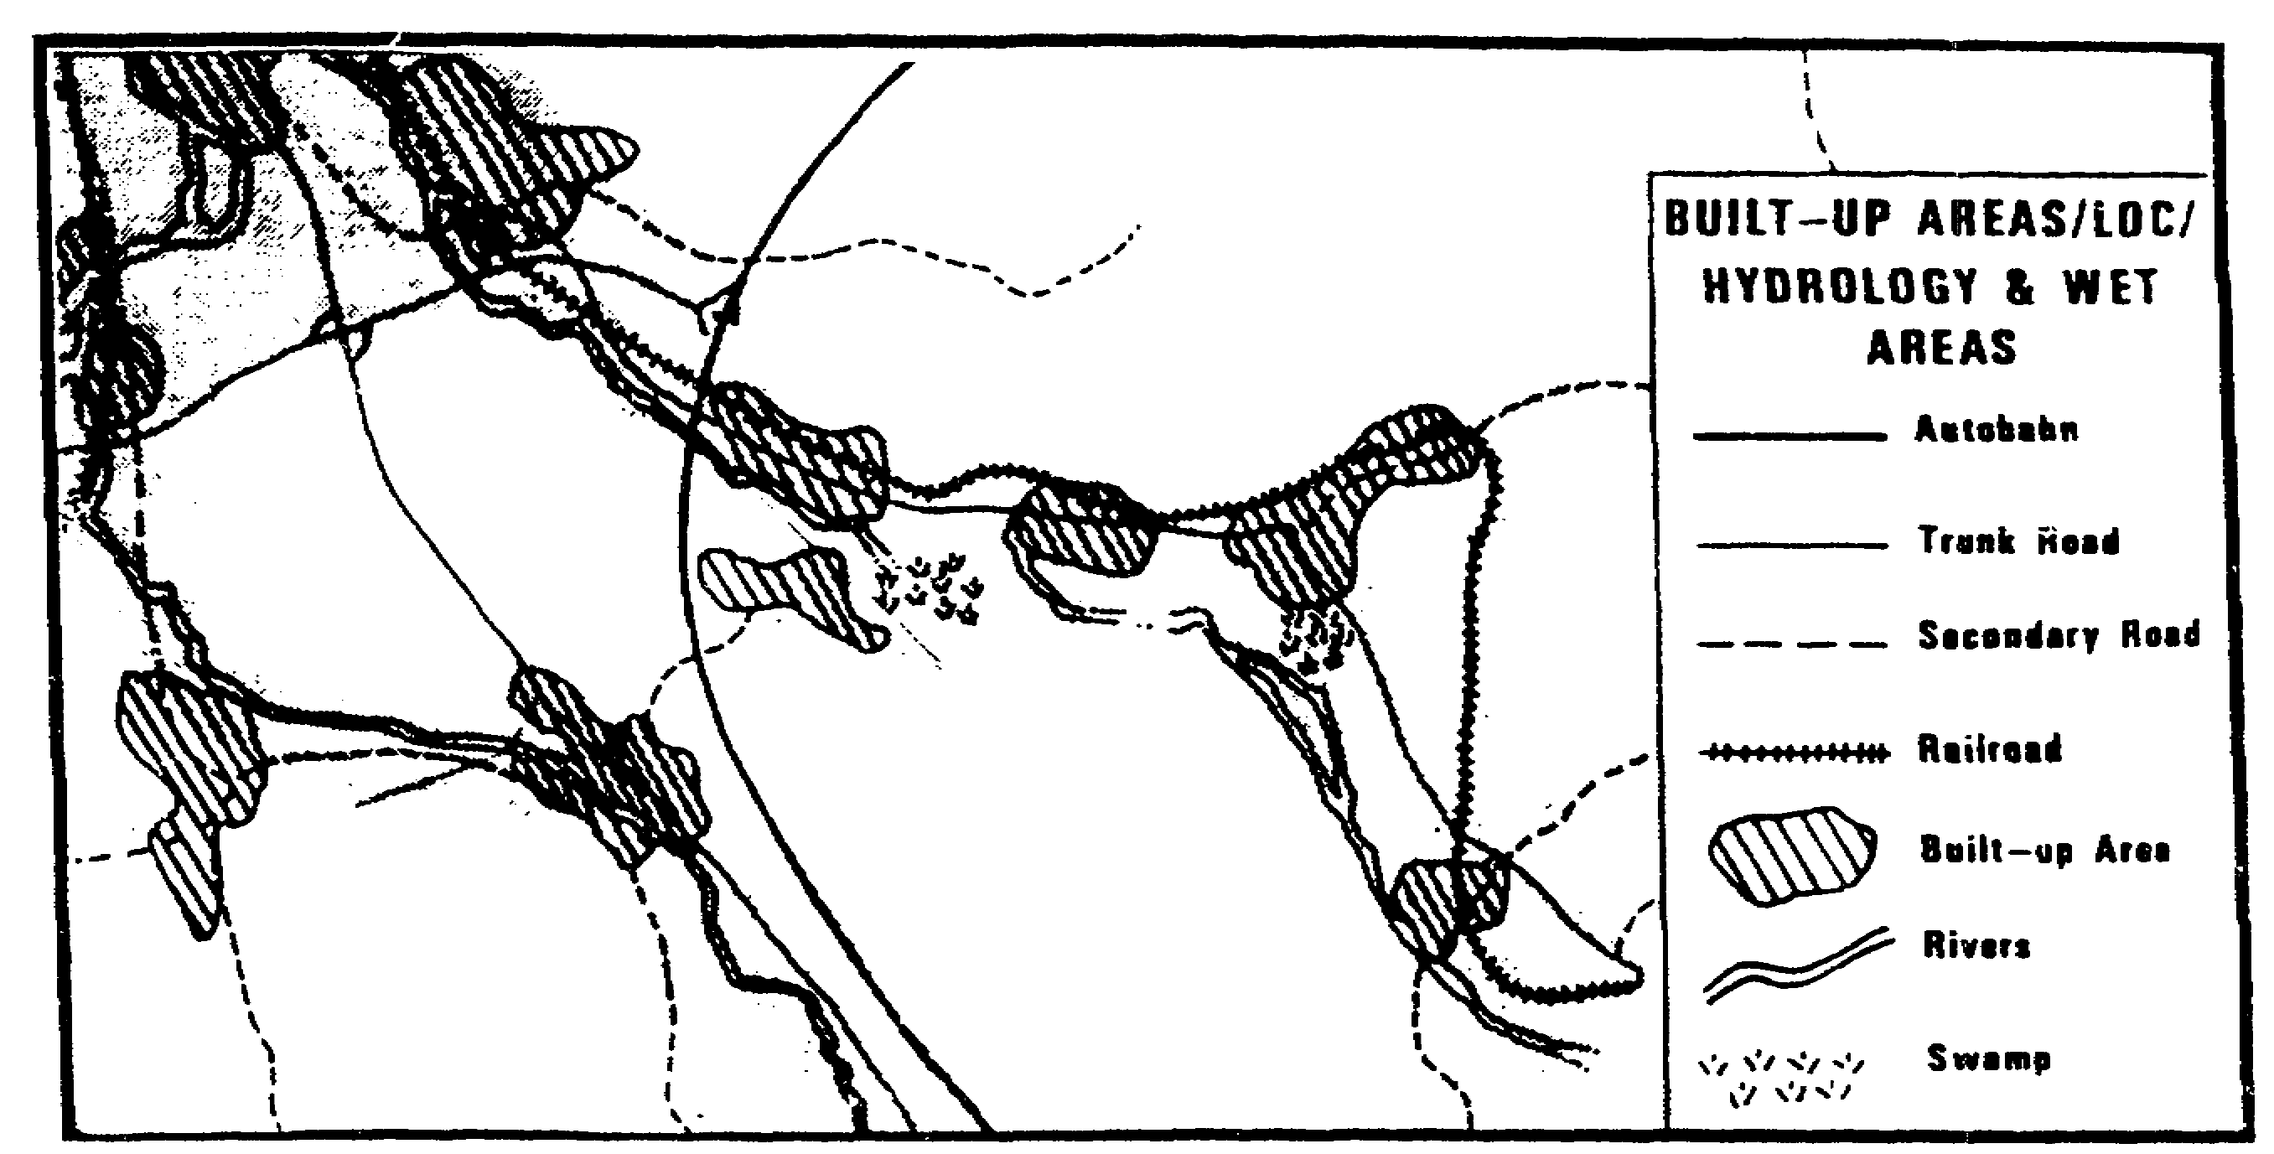

Figure 1-3. Precipitation Overlay.

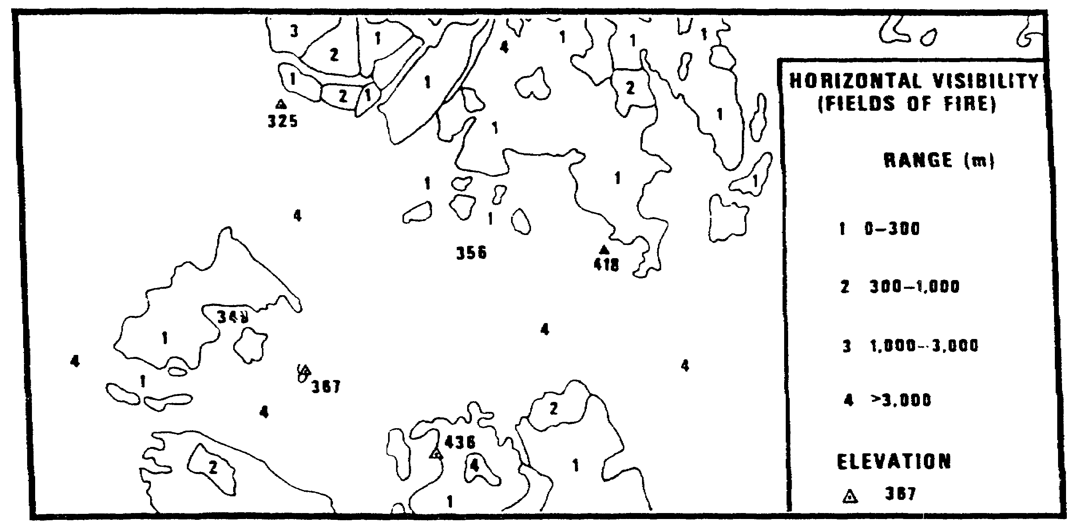

Figure 1-4. Visibility Overlay.

IT0426 1-24

The effects of fog on LOS is shown by overlaying it on a fields of fire overlay. In this case, fog limits visibility in those areas designated.

Ultimately, weather factor overlays are combined with terrain factor overlays to create a combined obstacle overlay (COO). The COO shows all the terrain obstacles, including those created by weather that can influence mobility. This overlay eventually aids in the development of mobility corridors, avenues of approach, and key terrain.

Cloud Cover Overlay. Cloud cover at low levels will have a significant impact on helicopter operations using air mobility corridors. It will also effect certain types of imagery collection systems, close air support and interdiction operations. Where mission success depends on visual LOS to objectives and targets, cloud cover can be an extremely important consideration, shown in figure 1-5 is an example of a cloud cover overlay. When combined with the canopy closure overlay, crosshatched lines show heavy density of cloud cover. The summer months show 50 to 80 percent cloud cover, and winter months show cloud cover to be greater than 80 percent. Arrowheads indicate the direction and speed of prevailing winds.

Severe Weather Overlays. Graphic models of severe weather such as thunderstorms squall lines, heavy rains, and strong winds are used in assessing their impact on proposed missions and operations.

Terrain-Influenced Wind Direction Overlays. Accurate surface wind information is a critical aspect of assessing enemy NBC capabilities and potential friendly forces use of smoke and tactical nuclear weapons.

Snow Depth Overlays. When used with terrain, slope, obstacle, and lines of communication overlays, snow depth graphics assist in determining friendly and enemy mobility capabilities.

Electromagnetic Propagation. The atmosphere's effect on the propagation of energy waves needs to be integrated into mission planning. The Radar waves are particularly affected by inversions and moisture layers. High frequency radio propagation depends on high atmosphere phenomena. Electro-optical, and millimeter wave devices are also affected. Weather graphics showing propagation through the lower atmosphere and high frequency radio Maximum Usable Frequency and Lowest Usable Frequency predictions are important in assessing enemy and friendly radar emission and detection capabilities.

1-25 IT0426

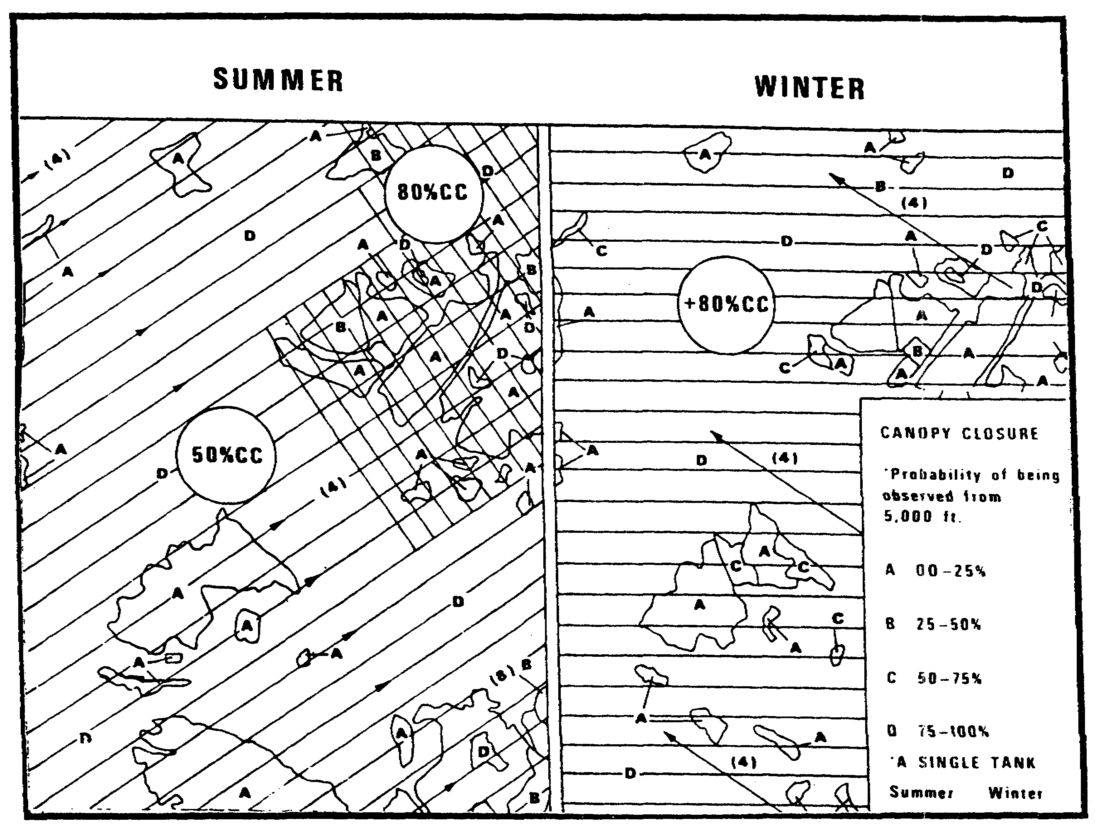

Figure 1-5. Cloud Cover Overlay.

Weather Factor Analysis Matrix. The weather factor analysis matrix (Table 6) illustrates intelligence weather factors that impact on terrain, mobility, and LOS (both optical and electronic).

IT0426 1-26

Table 6. Weather Factor Analysis Matrix.

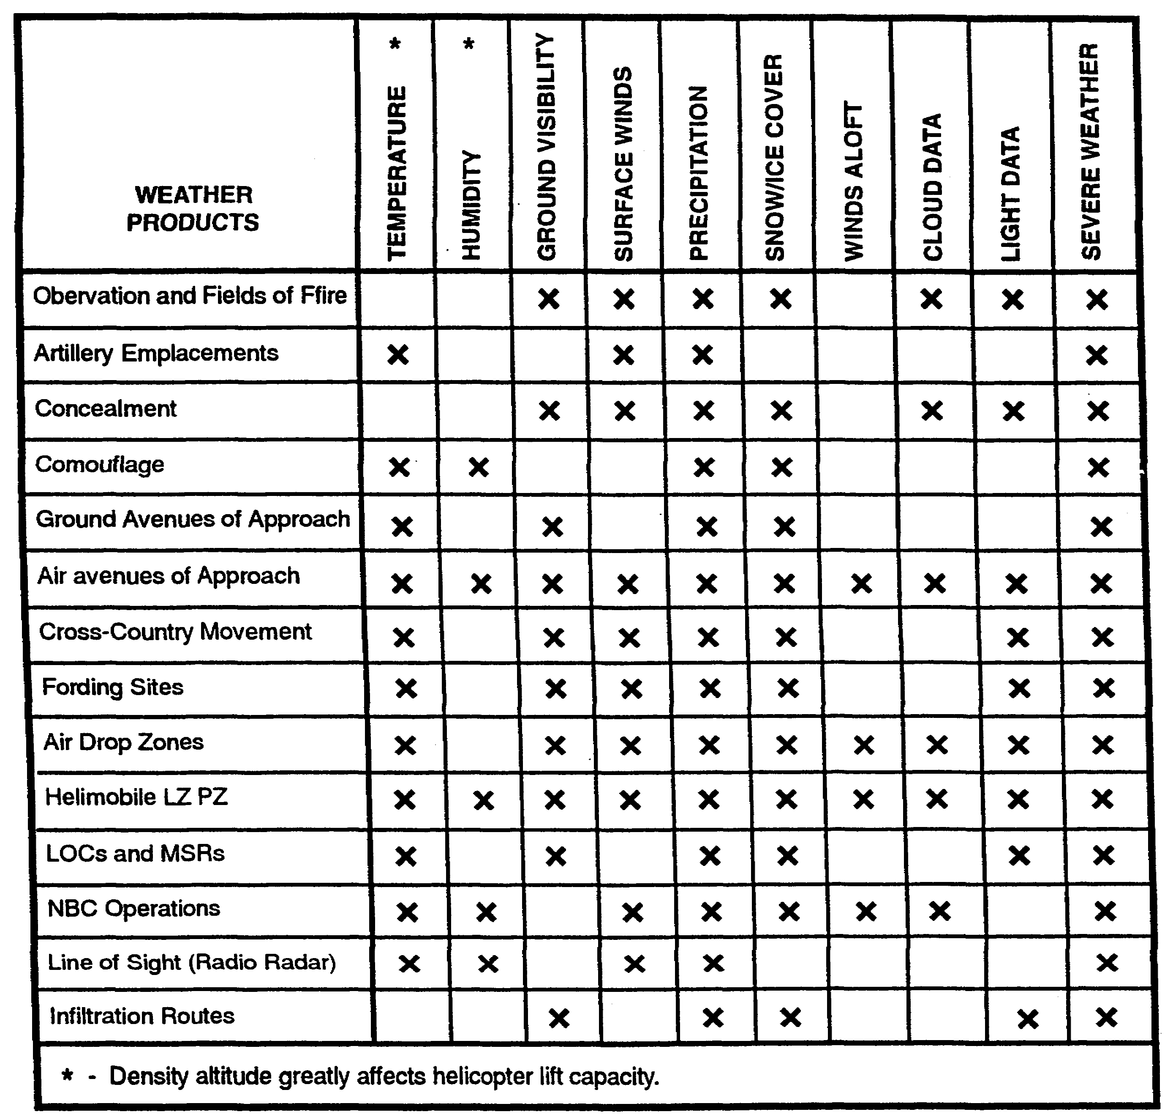

1-27 IT0426

MILITARY ASPECTS OF WEATHER

The military significance of weather parameters will normally vary with seasons. When analysts understand seasonal characteristics, they can focus on those seasonal periods. Depending on soil drainage and temperature conditions, there can be a significant impact on trafficability. For example, an operational area may have an average rainfall of 10 inches in the three summer months. If analysts use 10 inches of rainfall as the controlling average for determining trafficability, it may be concluded conditions will not support much movement during that period. In fact, on a closer look, one may find weather window. during the three-month summer period that would be very favorable to cross-country movement.

REMEMBER: It was a weather window during the Korean War that allowed the Inchon landing giving the allies the advantage to push the North Koreans back beyond the 38th parallel.

An understanding of the tactical significance of weather effects and the threats or opportunities implicit in them depends on the users' knowledge of weather data within the Army, the significant weather parameters, and the effects of the weather parameters on Army user operations.

Army Users of Weather Data. Sixteen Army users are compared with the effects of weather on selected operations (Table 8).

Significant Weather Parameters. Fifty-six weather and environmental parameters (35 surface and 21 aloft) have been identified (see Table 7).

IT0426 1-28

Table 7. Sources of Environmental and Meteorological Data.

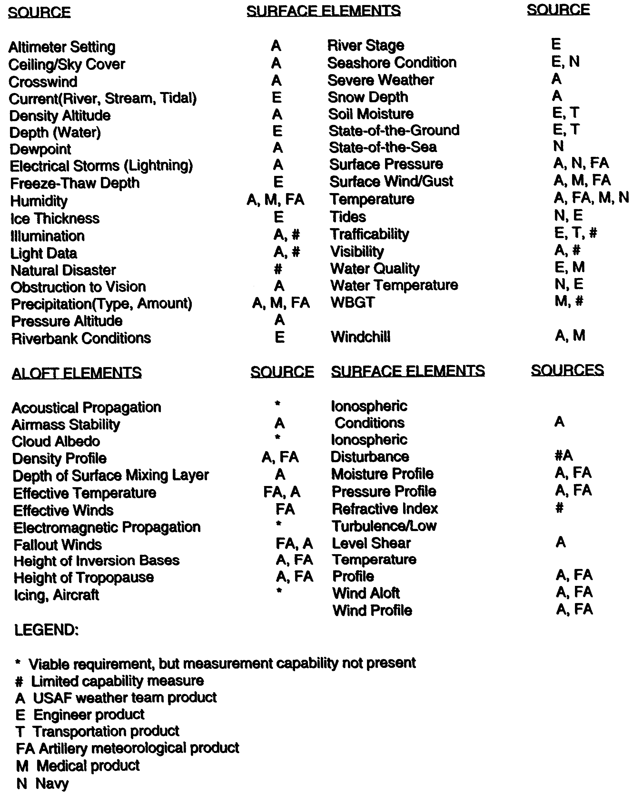

1-29 IT0426

Parameter-User Matrix. Forty environmental parameters which impact on Army operations have been identified. The weather parameters impacting on 20 of the Army users are shown on the parameter-user matrix (see Table 8). The command and staff user is not included in this figure because the decision-making process requires consideration of all the effects of the various weather parameters.

To understand the effects of the environment on tactical operations, it is necessary to determine how these parameters influence the operations. Generally, the 40 environmental parameters affect tactical operations as shown in Table 8. See Appendix A for a list of parameter definitions and effects on tactical operations.

Table 8. Parameter-User Matrix.

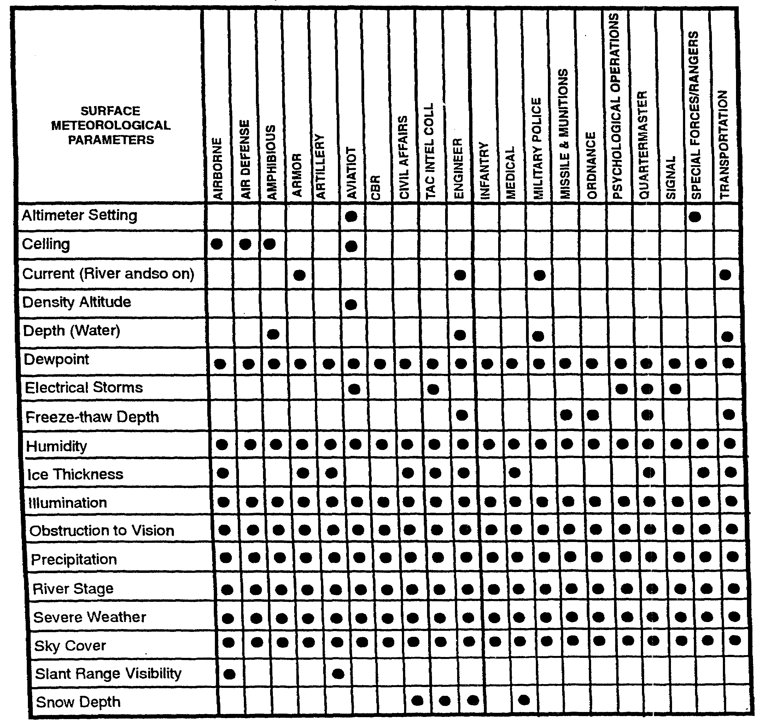

IT0426 1-30

Table 8. Parameter-User Matrix (Continued).

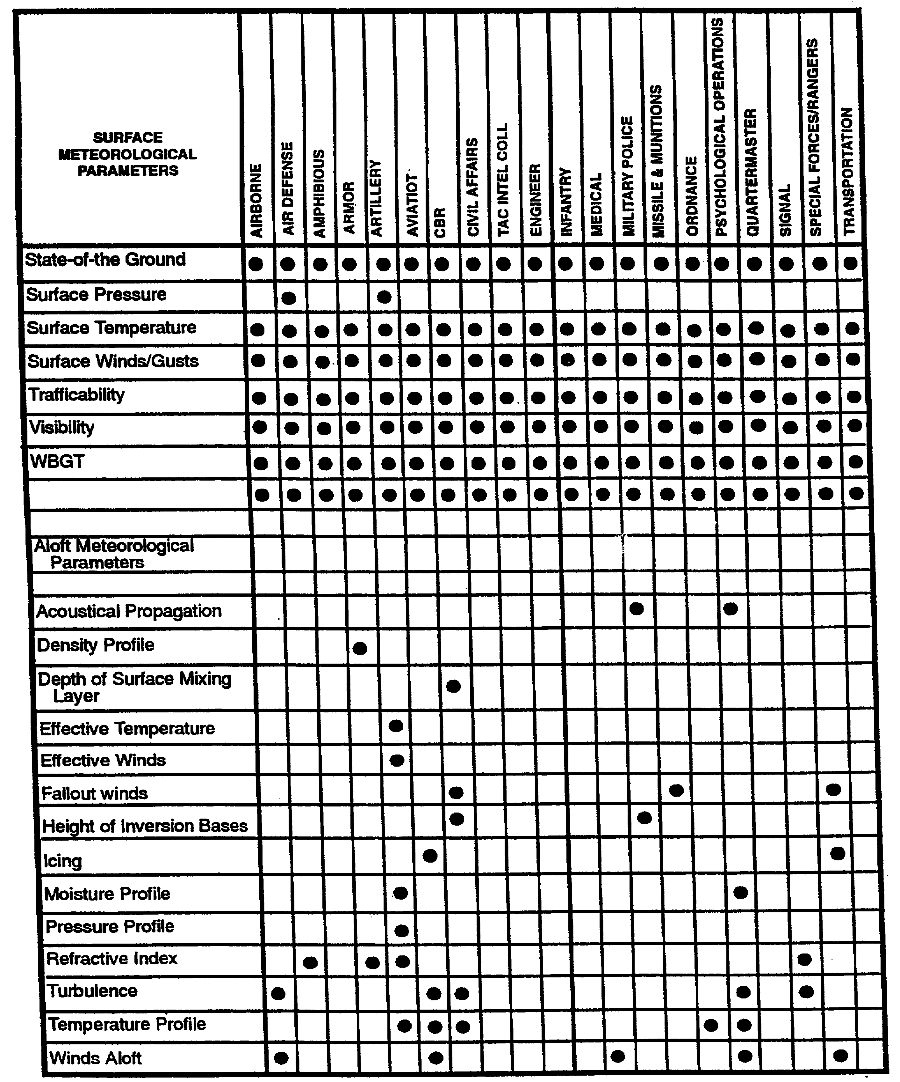

1-31 IT0426

LESSON

PRACTICE EXERCISE

The following items will test your grasp of the material covered in this lesson. There is only one correct answer for each item. When you have completed the exercise, check your answers with the answer key that follows. If you answer any item incorrectly, study again that part of the lesson which contains the portion involved.

1. Wind is measured by which of the following?

A. Humidity and speed.

B. Intensity and direction.

C. Visibility and temperature.

D. Direction and speed.

2. Which of the following terms would be used to report cloud cover of 0.60 to 0.90 percent of the sky?

A. Clear.

B. Broken.

C. Overcast.

D. Scattered.

3. Which of the following is a moderate rain?

A. 0.11 to 0.30 inch per hour.

B. 0.01 inch in 6 minutes.

C. More than 0.30 inch per hour.

D. 0.10 inch or less per hour.

IT0426 1-32

4. Generally, visibility at BMNT is which of the following?

A. Less than 100 meters.

B. 250 meters.

C. About 400 meters.

D. More than 500 meters.

5. What would the windchill temperature be if the temperature were 10°F and the wind were blowing at 20 knots?

A. -25°F.

B. -15°F.

C. -20°F.

D. -30°F.

6. Using the Beaufort Scale, what would be the approximate wind speed if small trees-in-leaf begin to sway?

A. 8-12 mph.

B. 13-18 mph.

C. 19-24 mph.

D. 32-38 mph.

7. Referring to the list of weather effects on operations in appendix A, which of the following tactical operations would be more affected by altimeter setting?

A. Air defense.

B. Armor.

C. Airmobile.

D. Military police.

1-33 IT0426

LESSON

PRACTICE EXERCISE

ANSWER KEY AND FEEDBACK

Item Correct Answer and Feedback

1. D. Wind is measured by direction and speed (page 1-8, para 8).

2. B. Broken clouds cover occurs when 0.60 to 0.09 percent of the sky is covered. (page 1-11, para 2).

3. A. A rainfall of 0.11 to 0.30 of an inch per hour is considered moderate
(page 1-13, para 4).

4. C. Generally, visibility at BMNT is about 400 meters (page 1-14, para 3).

5. A. -25° F. See Table 3, Wilndchill Index (page 1-15).

6. C. 19-24 MPH. See Table 1, Beaufort Scale (page 1-10).

7. C. Airmobile. See Appendix A, Weather Elements (page A-2).

IT0426 1-34

